`ME-Byblos- Egyptian figurine

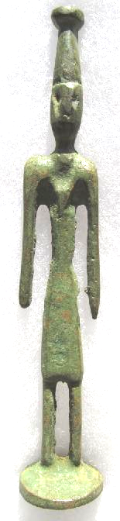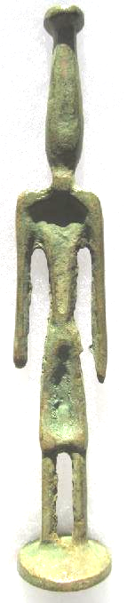 SHAPE \* MERGEFORMAT 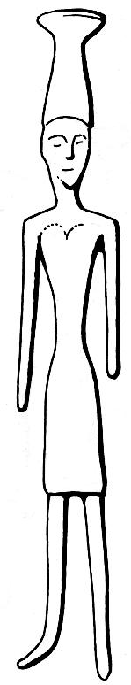

Figs. 1-2 Byblos bronze figurine of a ruler (?) second half of the 19th century BCE; Fig. 3, Byblos bronze figurine of a ruler (?) second half of the 19th century BCE excavated from the "Temple aux obélisques" at Byblos, after Negbi 1976:22, Fig. 29.

Byblos bronze figurine of a ruler (?) second half of the 19th century BCE, 13.73 cm., 5.4 in. high.

**Byblos** is the Greek name (Βύβλος) of the ancient Phoenician city of **Geb'El (**') that was first occupied between 8800 and 7000 BCE, with its name signifying that the god El had a role in its founding. Its Greek name is derived from the fact that papyrus was exported through Byblos to the Mediterranean and hence "Βύβλος" became associated with the word for "papyrus scroll". Byblos was a virtual colonial ally of Egypt, which used its timbers (cedars of Lebanon, ***Cedrus libani***) for tombs and boats (Watson and Bullard 1990: 124). Being one of the five cities of the Phoenician Pentapoleis, Byblos was a major maritime power, and its expertise in ship building was so well-respected in Egypt that in the sixth dynasty under Pepi II (2284 - 2184 BCE; revised dating from Clayton 2006: 64) an ocean going "Byblos ship" was constructed to reach Punt (Säve-Söderbergh 1946:11).

The extensive trade and exchange between Byblos and Egypt beginning in at least the sixth dynasty of Egypt provides the background of the present figurine. Nearly seven hundred bronze figurines with headdresses reminiscent of the Egyptian crown of Upper Egypt have been excavated from the tombs of Abishemu and Ypshemuiabi dated to the reigns of the Egyptian Pharaohs Amenemhat III (1842-1797 BCE) and Amenemhat IV (1798-1790 BCE) respectively (Montet 1928-1929: 155, 157). While there is demonstrable Egyptian iconography in these figurines, they all share in the elongated style of Phoenician figural design (Hansen 1969:284). The particular figurine we have here has a close counterpart of a figurine that was excavated from the "Temple aux obélisques" at Byblos (Negbi 1976:22, Fig. 29; 156, no. 530; see Fig. 4 below).

References:

Clayton, Peter A. 2006. Chronicle of the Pharaohs: The Reign-by-Reign Record of the Rulers and Dynasties of Ancient Egypt. London: Thames & Hudson. 2006.

Hansen, D. P. 1969. Some remarks on the chronology and style of objects from Byblos, *American Journal of Archaeology*, 73:281-284.

Montet, P. 1928-1929. *Byblos et l'Égypte. Quatre campagnes de fouilles à Gebeil, 1921-1922-1923-1924*. Paris: P. Geuthner, 1928-29.

Moran, William L. 1992. *The Amarna Letters*. Baltimore: Johns Hopkins University Press.

Negbi, Ora. 1976. *Canaanite gods in metal: an archaeological study of ancient Syro-Palestinian figurines.* Tel Aviv: Tel Aviv University, Institute of Archaeology.

Mills, Watson E., Bullard, Roger Aubrey. 1990. *Mercer dictionary of the Bible*. Mercer University Press

Säve-Söderbergh, Torgny. 1946. *The navy of the eighteenth Egyptian dynasty*. Uppsala : Lundequistska Bokhandeln ; Leipzig : Otto Harrassowitz, 1946.